AS**SIGNMENT#02** MAJID HUSSAIN

ROLL NO: 0062

**SINGLETON PATTERN**

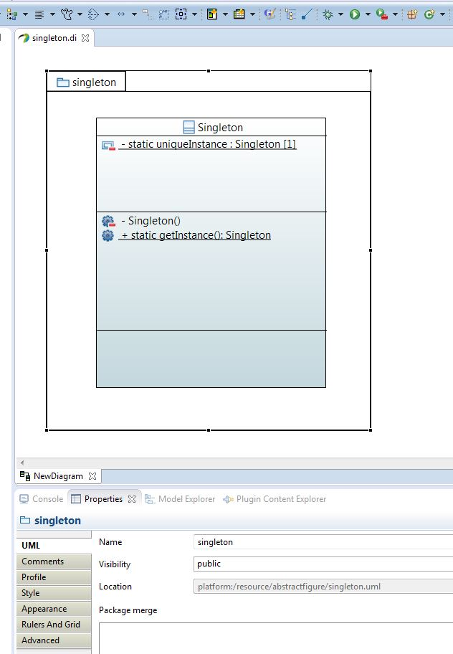

**FACTORY PATTERN**

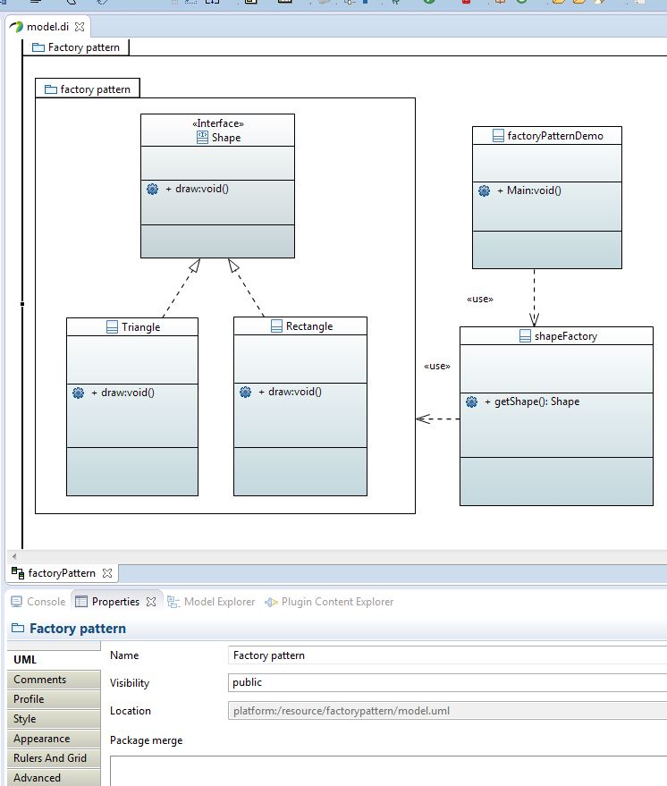

**ADAPTER PATTERN**

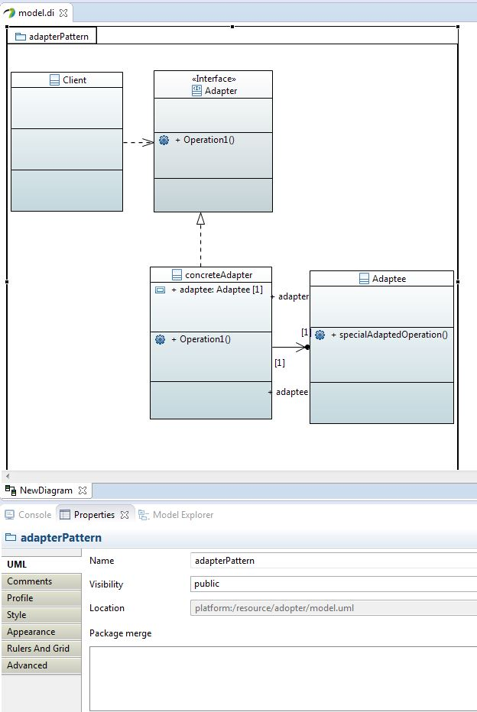

**Decorator PATTERN**

